**2.1.1 Examination of RINEX Data Sets**

*BASE1600.16o*

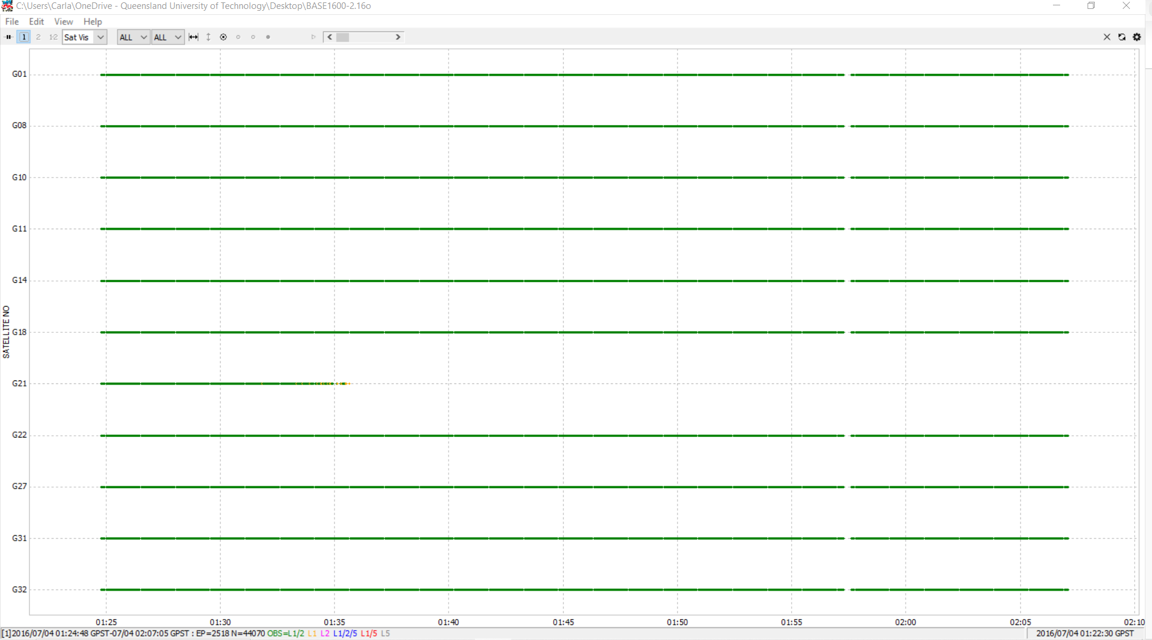

1. 2016/07/04 01:22:30 GPST.
2. OBS = L1/2 L1 L2 L1/5 L5

* **L1/2**: Dual-frequency carrier phase observation (L1 and L2).
* **L1**: Single-frequency carrier phase on L1.
* **L2**: Carrier phase observation on L2.
* **L1/5**: Observation combining L1 and L5.
* **L5**: Single-frequency carrier phase observation on L5.

1. Approximately from 01:25 to 02:10 GPST, sample rate is around 1 second.

***ROAD1600.16o***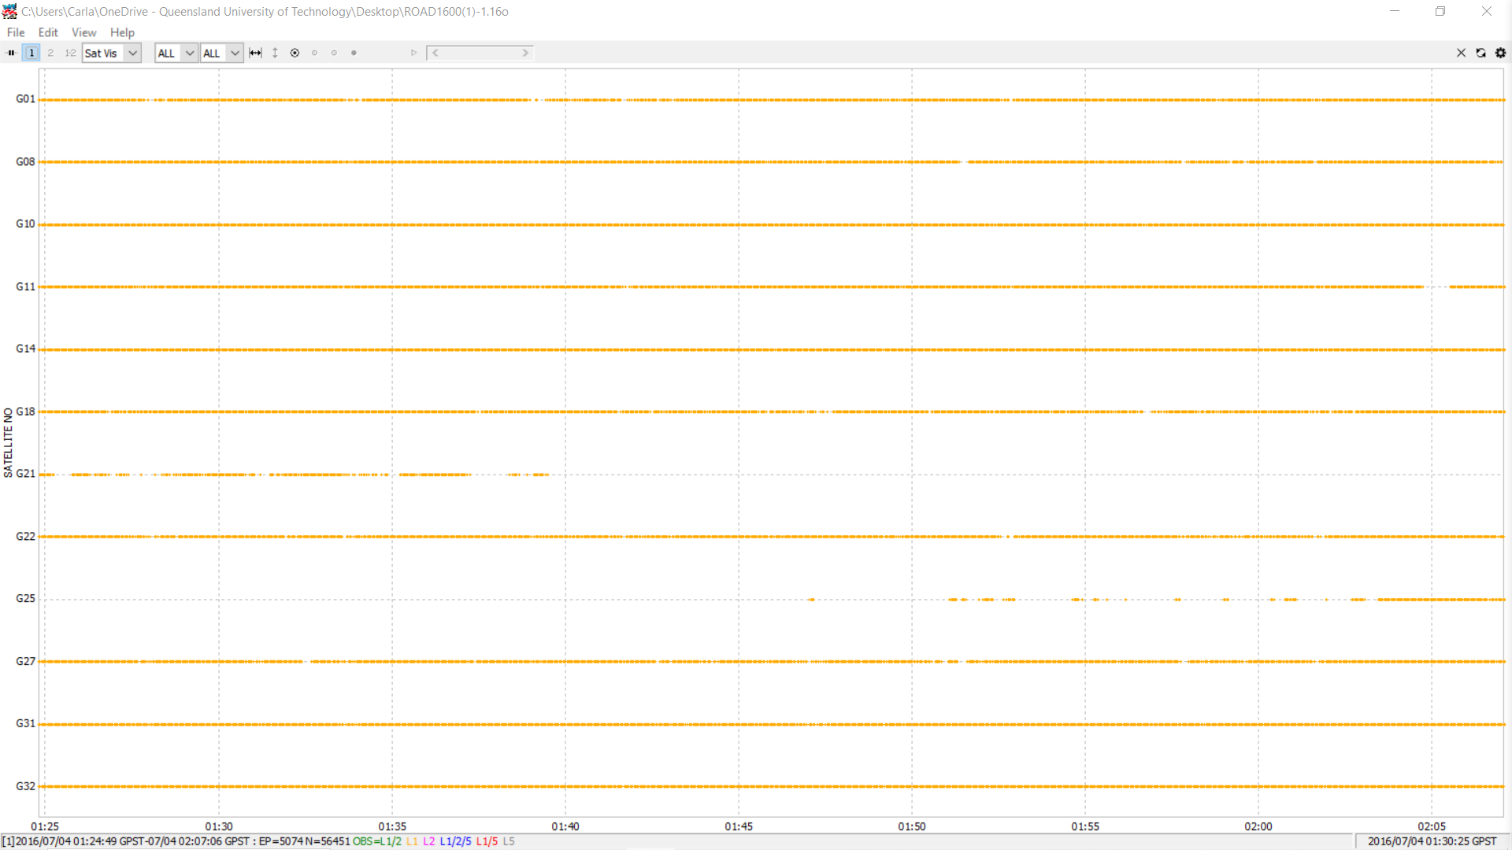

1. 2016/07/04 01:30:25 GPST
2. OBS = L1/2 L1 L2 L1/5 L5

* **L1/2**: Dual-frequency carrier phase on L1 and L2.
* **L1**: Carrier phase on L1.
* **L2**: Carrier phase on L2.
* **L1/5**: Observation combining L1 and L5 frequencies.
* **L5**: Carrier phase observation on L5.

1. From **01:25 to 02:10 GPST**, sample rate is around 1 second with small intervals between data points.

2.1.2 Visualization and Discussion using RTKPLOT: **ROAD1600.16o**

b) Skyplots for L1 signals of all visible satellites

**Good Satellite Distribution:** They are well distributed across the sky, so there is a good range of azimuth and elevation values. It improved positioning accuracy as the geometric configuration is strong.

**Signal Blockage:** If the satellite arcs are incomplete, it reveals moments when the receiver lost track of those satellites, which may lead to temporary decreases in accuracy or even gaps in the positioning solution.

c) DOP (Dilution of Precision) and satellite count (NSAT) for all satellites

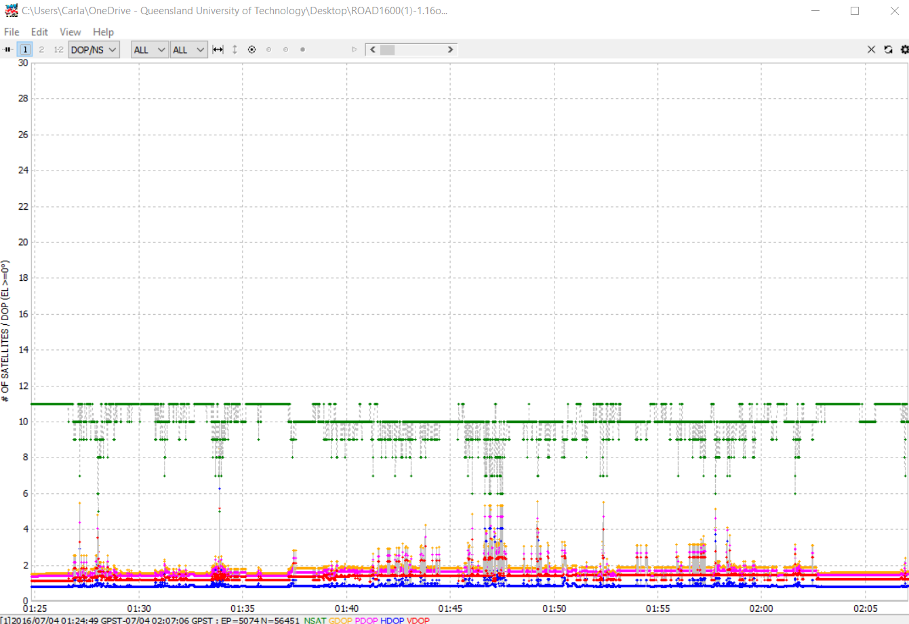

**NSAT (Satellite Count):** The green line shows that satellite visibility is generally stable but has some brief drops, which might momentarily affect positioning accuracy.

**Good Satellite Geometry:**The overall low DOP values show good satellite geometry, which means that the satellites are spread out well across the sky, reducing positional error.

**2.1.3 Positioning Analysis with RTKPOST**

a) Plots of ground track and position for all three modes.

* Single

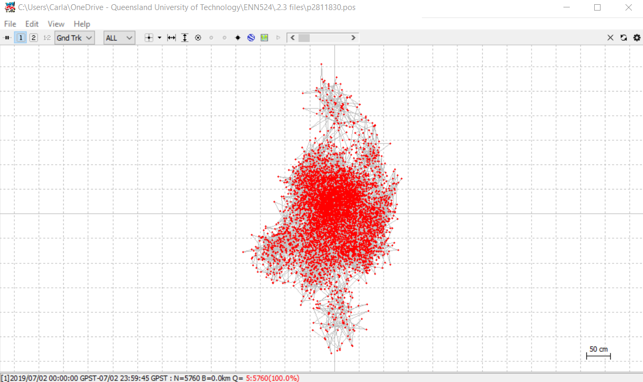

* Kinematic

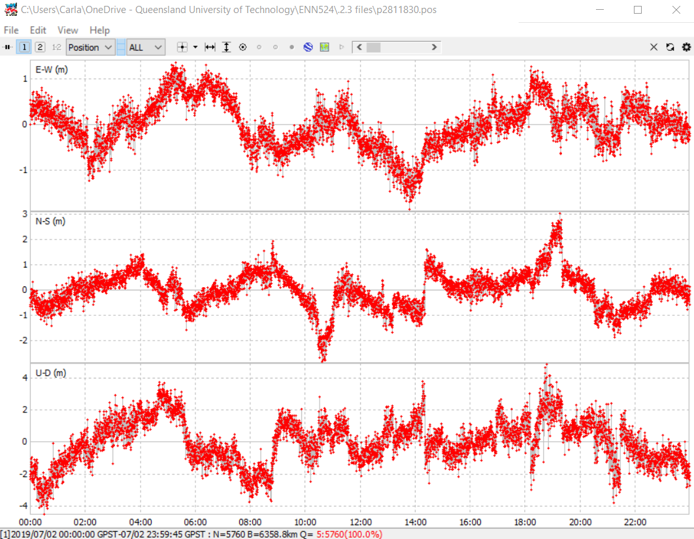

* Static

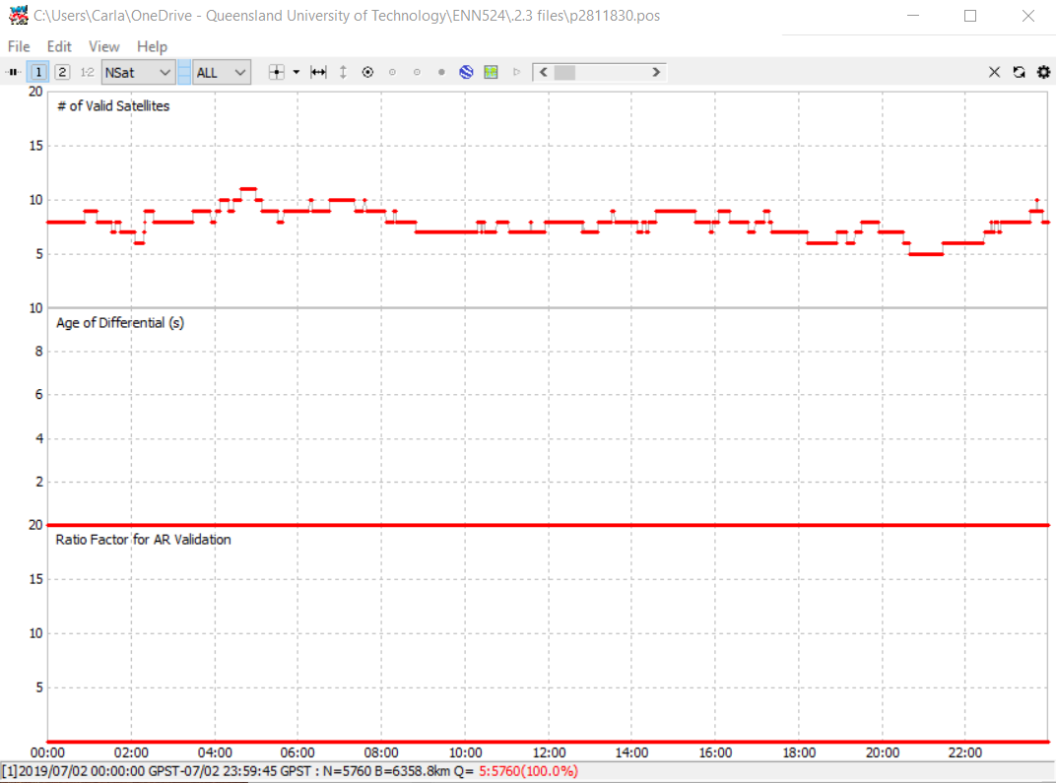

b) Comparison of position and ground track results, discussing the accuracy of each mode.

* **Kinematic mode:** It showsa good balance between accuracy and mobility, offering a clean and precise ground track.
* **Single mode:** It shows less accurate with noticeable drift and scatter in the positioning data.
* **Static mode:** It performs the most accurate results as it minimizes errors over time.

c) RMS values for positioning errors in East-West, North-South, and Up-Down directions (Sigma for stdn, stde, and stdu).

* **Kinematic mode:** It offers low RMS errors in horizontal positioning with some increase in the vertical direction.
* **Single mode:** It has higher RMS errors, especially in the Up-Down direction.
* **Static mode:** It shows minimal errors across all directions.

d) Evaluate the impact of changing the elevation mask angle to 5 degrees on the positioning results.

Lowering the elevation mask to 5 degrees increases satellite visibility but introduces more noise, especially in **Single mode**, due to low-elevation satellites. The influence is less severe in **Kinematic mode**, and **Static mode** shows the least degradation.

**2.1.4** **Comparative Analysis using Road and Drone Data**

a) Single positioning mode with drone and road data.

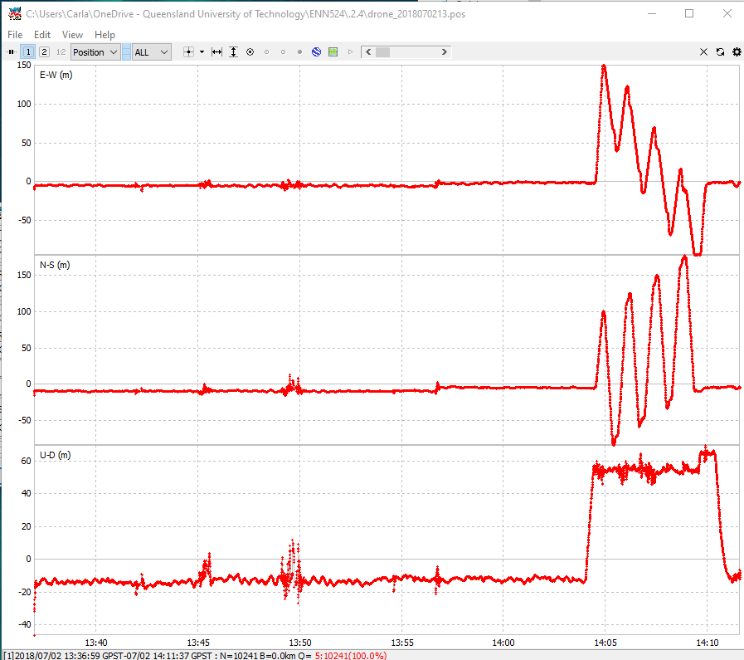

The plot for the drone data shows significant fluctuations in the East-West (E-W), North-South (N-S), and Up-Down (U-D) directions around the time between 13:40 and 14:10 GPST.

Large spikes appear in the E-W and N-S directions around 14:05 GPST. These are likely artifacts of either poor satellite geometry or a signal disruption, causing the position to deviate significantly.

b) Kinematic positioning mode with base station and moving data files.

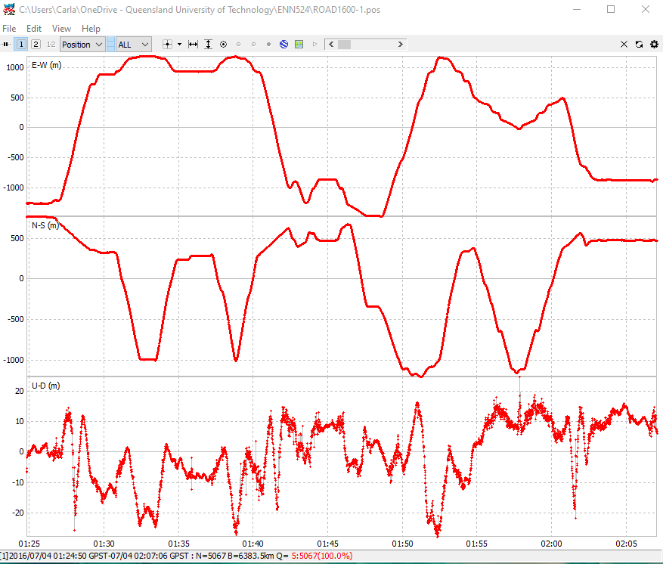

The road data plot shows more stable fluctuations in the E-W, N-S, and U-D components compared to the drone data. However, it still displays notable undulations over the observation period from 01:24 to 02:07 GPST.

c) Compare and discuss findings from both plot sets

The comparison between the drone and road data shows differences in positional stability. The drone data displays large positional spikes, especially in the East-West (E-W) and North-South (N-S) directions, with considerable fluctuations in the vertical (Up-Down) direction, particularly after 14:05 GPST. In contrast, the road data shows smoother and more stable positional changes across all components, with smaller deviations in the vertical direction, indicating better satellite coverage and signal conditions. The constrained movement of the road vehicle and its clearer line of sight to satellites contributed to more accurate positioning. In summary, the drone data's dynamic flight path led to greater instability, while the road data was more reliable and consistent.

**Question 2.2 Exploring and Analyzing Variations in Australian CORS Station Coordinates for 2022 (3%)**

**2.2.1 Coordinate System Explanation**

I choose GDA2020 as my coordinate system to analyse this project. Because it is the official geodetic datum for Australia, providing a modern, earth-centered reference frame that aligns closely with the International Terrestrial Reference Frame (ITRF).

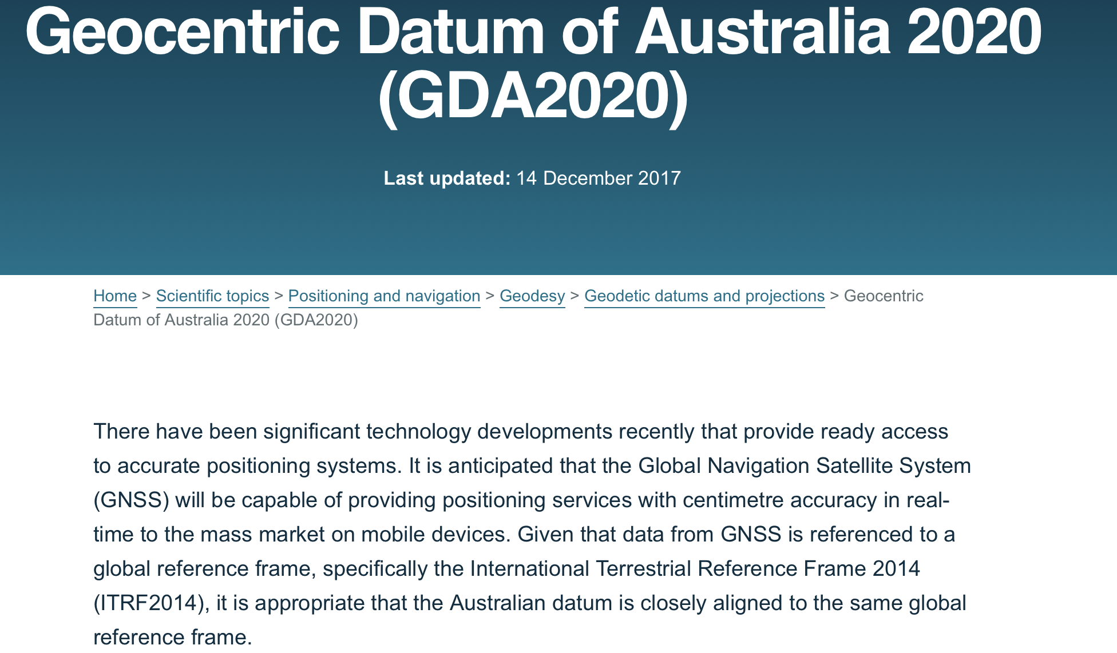

**2.2.2 CORS Selection Justification & AUSPOS Service Process Description**

Firstly, I downloaded RINEX observation files for three specific days (Day 001, Day 181, and Day 365) for the chosen CORS station: CNDO, because this station available RINEX files on the three dates, not every station does. I search start date from 01.01.2022 to 31.12.2022, only attracting three date of files: 01.01, 01.07, 31.12.

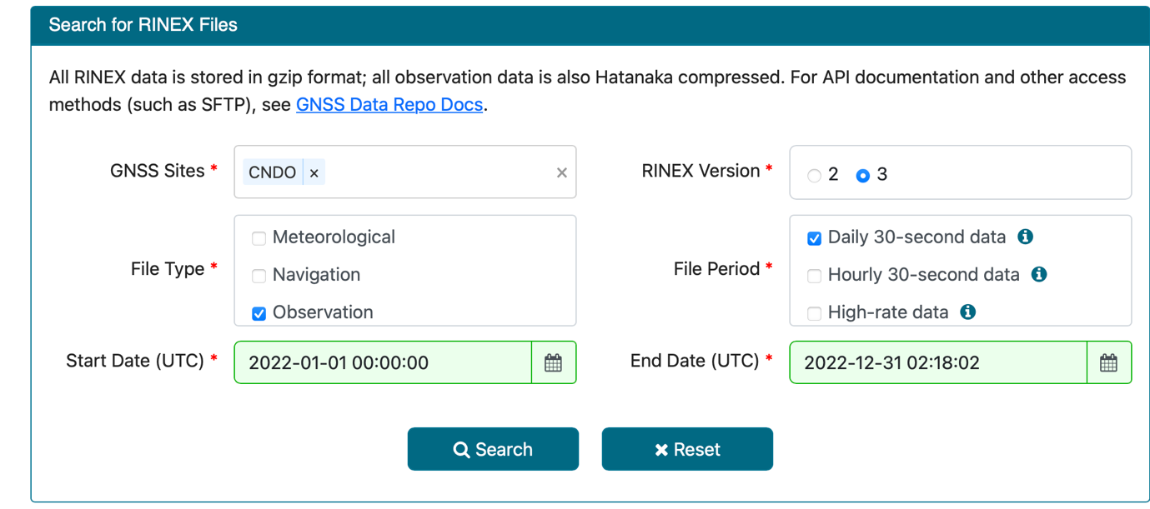

Then, I uploaded orderly the three RINEX files to the AUSPOS service, ensuring that the files were correctly formatted.

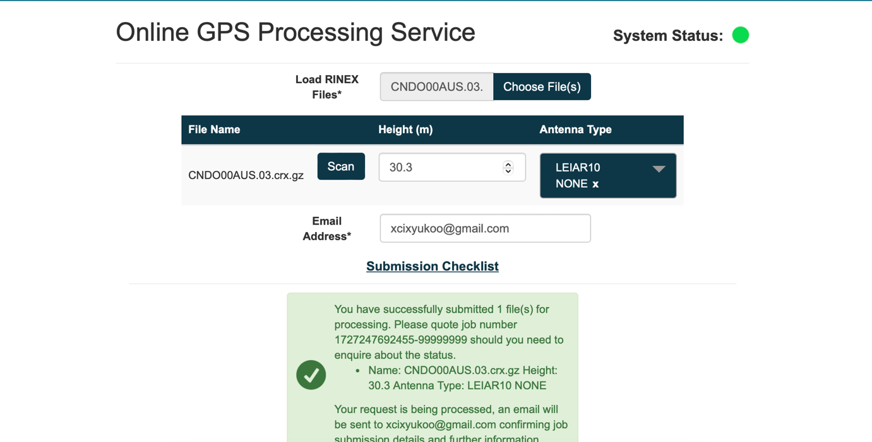

However, before submitting, I have to rename the file to match the system’s requirement; also, fill up lost information of antenna type and height by checking on following page: GNSS Site Manager.

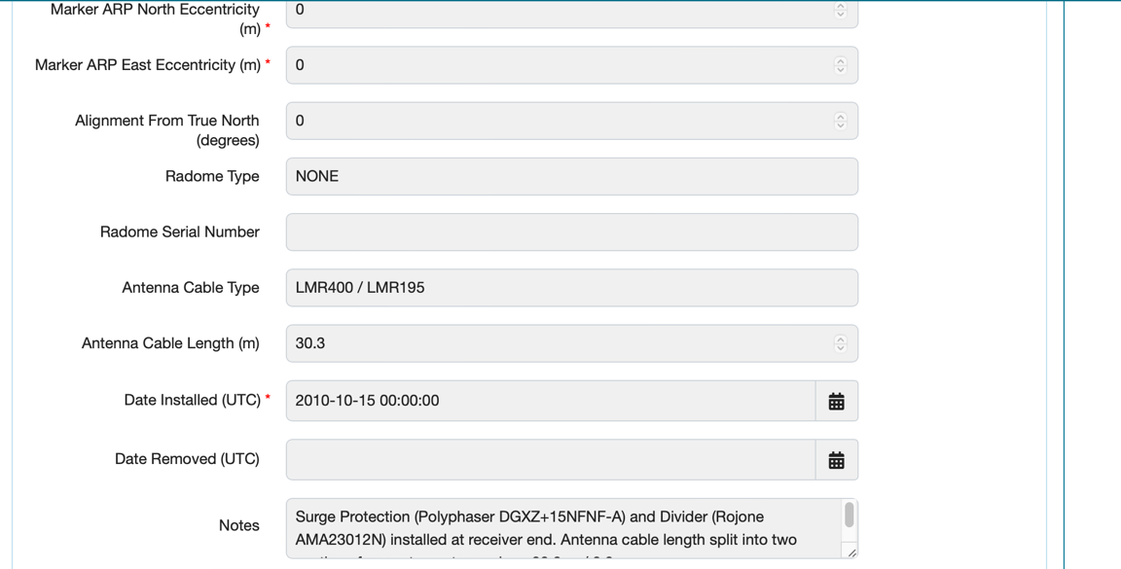

Finally, I got three emails with analysis result separately from AUSPOS system, which means the data has being process successfully.

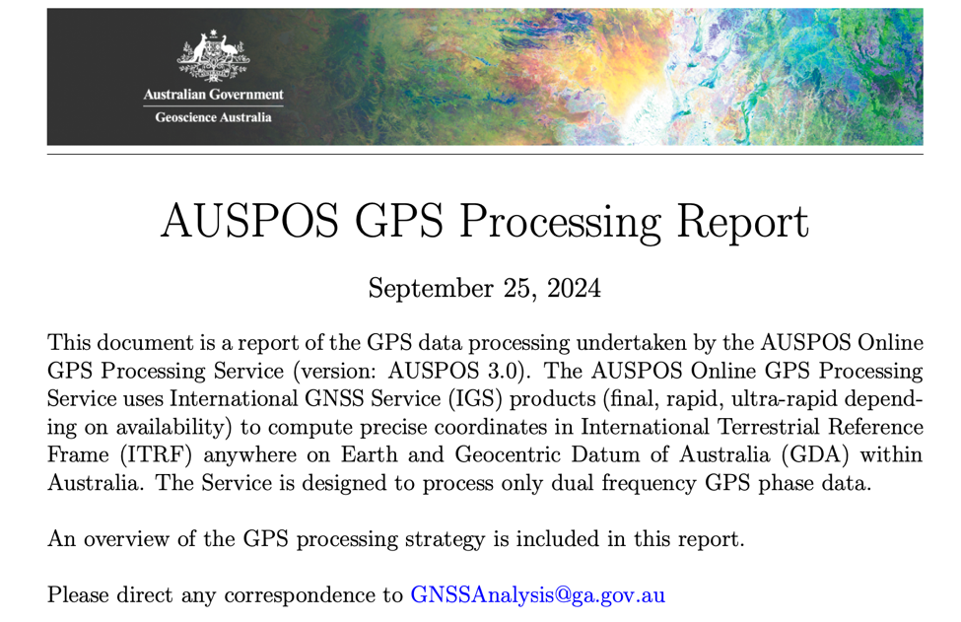

**2.2.3 Coordinate Presentation**

Based on the analysis from AUSPOS system, the differences of location in each date record are within 0.006 meters (6 mm), showing remarkable stability across datasets.

*01.01.2022*

X: -4494125.391, Y: 2901707.733, Z: -3461983.704

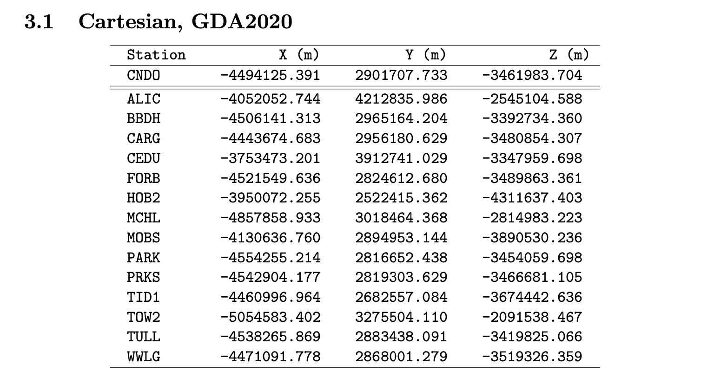

*01.07.2022*

X: -4494125.389, Y: 2901707.737, Z: -3461983.701

*31.12.2022*

X: -4494125.385, Y: 2901707.732, Z: -3461983.698

**2.2.4 Discussion of Results**

*01.01.2022*

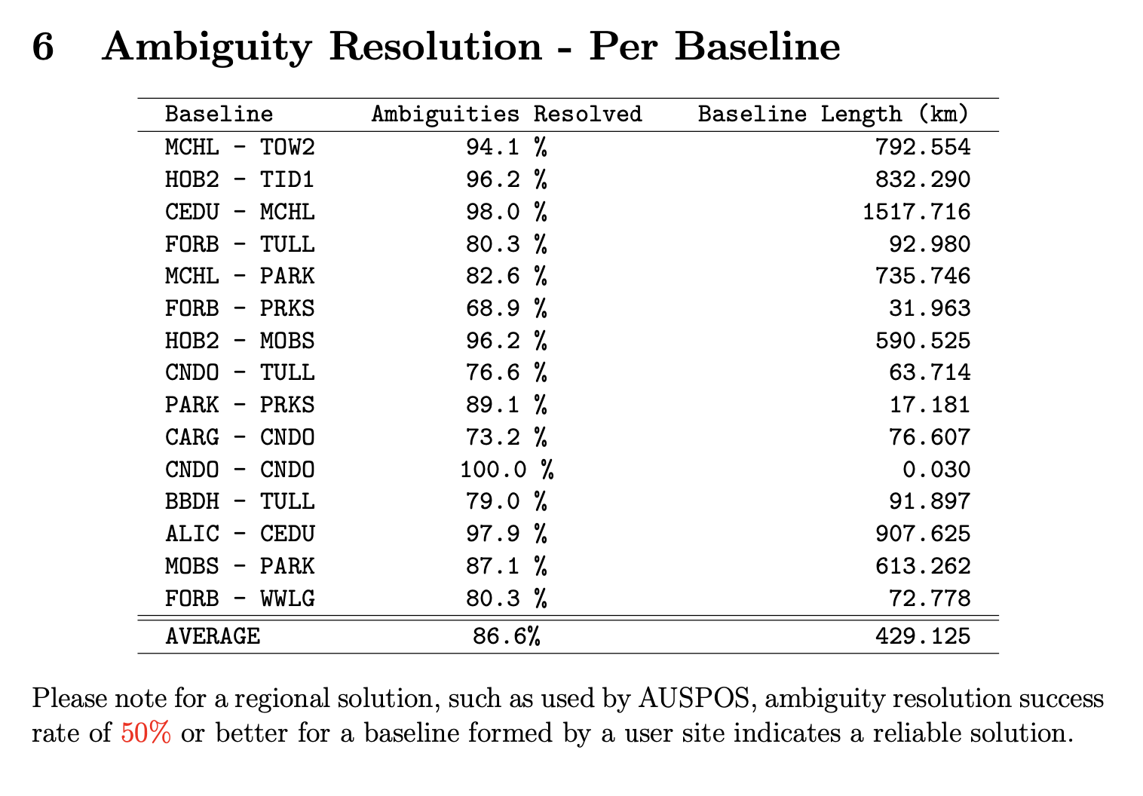

*01.07.2022*

*31.12.2022*

The ambiguity resolution success rates show a high level of reliability in the coordinate solutions, with an average success rate above 86%. While most baselines exhibit robust ambiguity resolution, certain baselines like FORB - PRKS show lower success rates. Overall, the coordinate solutions derived from these baselines are accurate and trustworthy for geospatial analysis.

**Summary Reflection**

Throughout the completion of Question 2.1 and Question 2.2, I gained a deeper understanding of GNSS data processing and positioning techniques. In Question 2.1, I explored the use of RTKLIB software to process GNSS data, focusing on static, kinematic, and single positioning modes. The detailed analysis of RINEX data sets, satellite visibility, and position plotting provided hands-on experience with interpreting real-world GNSS data. In Question 2.2, I have successfully found the suitable station data by myself and let AUSPOS to process, which bring me a lot of confidence as I never know such technology before. I learned that CORS stations provide highly reliable reference points for GNSS positioning. However, allow the system processing just the first step while understanding the report of data result with vary proper nouns is the hardest part in this section. Therefore, with this chance, I will have to read more reference and articles about how GNSS data working in modern society with IT technology so that I can feel more how big step is I have taken.